Assemblage Planner and Criteria Name ________________________________
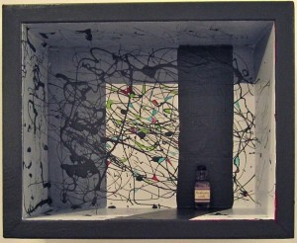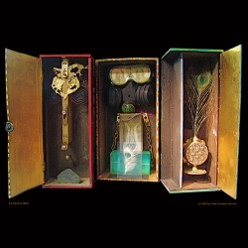
Use this sheet to help you plan your box art in your sketchbook. Remember EVERY single choice you make must have a reason behind it. EVERYTHING in your box art piece must connect to your life challenge and inner power.
My chosen life challenge is (brief summary): __________________________________________________________________________________________________________________________________________________________________________________________________________________________________________________
The inner power I used to deal with the challenge was: _____________________________________________________
Your plan must contain:
Colors List | Meaning of the color
(Example) Red | (Example) I chose red as it represents how angry I felt when my friend treated me badly.

Shapes list | Meaning of your shapes
(Example)Triangle | (Example)The triangle represents the three people that were involved in my life challenge, as it has three sides

Materials list | Meaning of your materials
(Example) Rough sack cloth | (Example) I chose this material because the texture was rough. This was how I felt my feelings were treated during my life challenge.

Objects | Meaning of your objects
(Example) Smooth stone | (Example) I chose a smooth stone because it represents my inner power. It reminds me of how calm I was able to be during my life challenge. I feel calm when I touch this stone.

Position | Meaning of the position of objects
(Example) Smooth stone is in the foreground of my box in the middle. | (Example) I chose this position because it is the most important object. I did not want it to be in shadow at the back of the box as it represented my inner power of calm.

